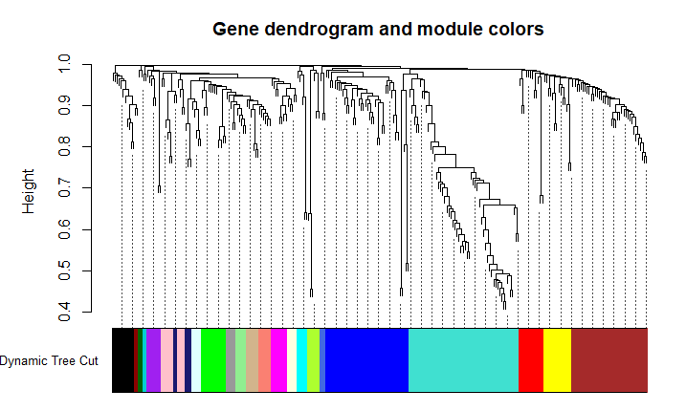

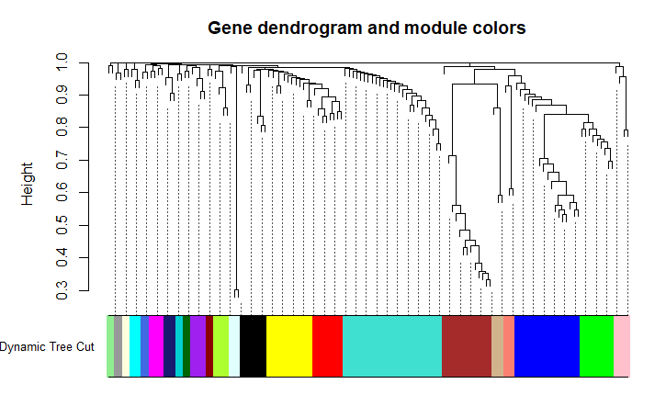

Supplementary Figure 4 – Gene dendrogram and modules for WGCNA for a) 2000 and b) 2015 data. The genes not assigned to any cluster have been removed. The minimum cluster size given is 2.